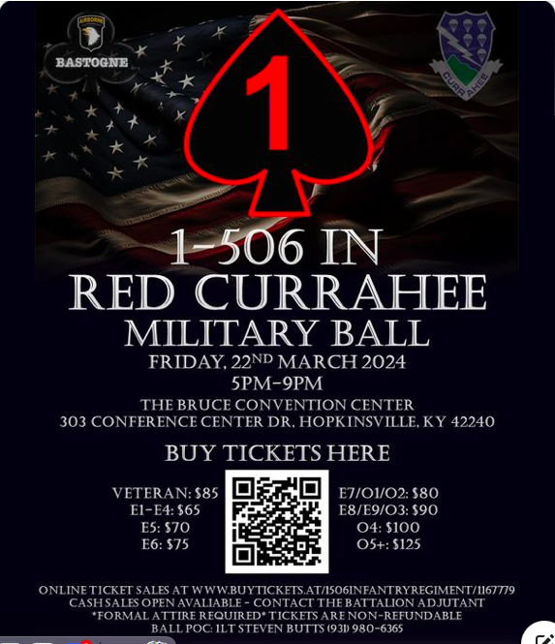

Friends and Families,
Please join us for the 2024 Red Currahee Battalion Ball on 22 March 2024 at "The James E. Bruce Convention Center". ONLINE TICKET SALES NOW OPEN!
https://buytickets.at/1506infantryregiment/1167779
#Currahee #standsalone #1BCT #bastogne #honorandcountry#ScreamingEagles #airassault #battalionball #redcurrahee #usarmy#fortcampbell

